Background
This will create checkbox’s that when clicked will show or hide certain (bookmarked) sections of a document, based on if the Yes_No checkbox is selected.
- Ensure document is saved as macro enabled file
File ->Save as-> Choose “Word Macro-Enabled Document” under Save as type
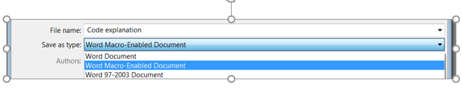

- Identify desired section to be hidden, and Bookmark it as follows
Highlight desired section -> under Insert tab -> Bookmark
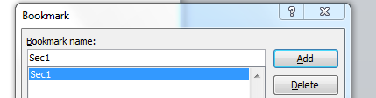

In the dialog box, type a name for the section. Then press “Add”.

- Create Checkbox object
Under Developer tab -> Controls ->Legacy Tools -> Create Check Box (ActionX Control )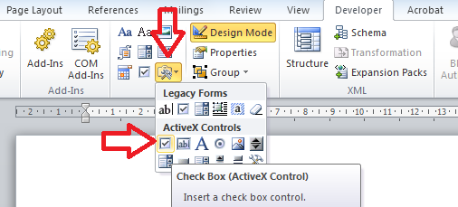
- Ensure Design Mode is enabled (yellow when on)
Developer tab -> Design Mode ->
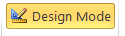

- Change internal name (or code reference) of the Checkbox object
Right click the checkbox -> select Properties ->
Go to the top row of the dialog box. It is row marked as “(Name)”. Input the desired name in the second column. Use underscores for spaces.
THIS NAME IS WHAT IS USED IN THE CODE
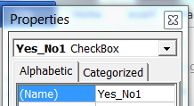
- Code the checkbox (make sure Design Mode is selected)
Right-click Checkbox -> View Code
delete all existing code (i.e., make it blank), then
copy and paste content under CODE TO COPY (found below)
change checkbox name (see highlight yellow) and bookmark name (see green highlight)
CODE TO COPY

Sub HideSection(strBkMrk As String)
ActiveDocument.Bookmarks(strBkMrk).Range.Font.Hidden = True
End Sub

Sub ShowSection(strBkMrk As String)
ActiveDocument.Bookmarks(strBkMrk).Range.Font.Hidden = False
End Sub

Private Sub Yes_No1_Click() ‘[CHANGE TO CHECKBOX NAME]
strBkMrk = "Sec1" ‘[CHANGE TO BOOKMARK NAME]
For Each bkMrk In Split(strBkMrk, ",")
If Yes_No1.Value = True Then ‘[CHANGE TO CHECKBOX NAME]
ShowSection (bkMrk)
Else
HideSection (bkMrk)
End If
Next

End Sub

- Turn off Design Mode before saving
This will activate the checkboxes. Finish!

- Change name of Checkbox – this is more for aesthetics (not coding)
Right click the checkbox -> select Checkbox Object -> Edit ->
